## UNION CHRISTIAN COLLEGE ALUVA

[Re-accredited with A grade by National Assessment and Accreditation Council (NAAC)]



#### HALL BOOKING

REPORT OF MINI PROJECT

Submitted in partial fulfilment of the requirement for the award of the degree of

## B.Sc. COMPUTER SCIENCE

By Mahatma Gandhi University, Kottayam during 2017-2020

Submitted By,

#### ABDUL MUBEEN & AMAL .P. FRANGLIN

#### Reg. No. :

#### ABDUL MUBEEN: 170021046441

#### AMAL .P. FRANGLIN: 170021046449

Under the guidance of **Mr. CIJIN K PAUL**

## UNION CHRISTIAN COLLEGE ALUVA

(Affiliated to Mahatma Gandhi University)



##### Department of Computer Science

**CERTIFICATE**

This is to certify that the MINI PROJECT entitled “**HALL BOOKING**” submitted by **ABDUL MUBEEN** (Reg No. : 170021046441) and **AMAL .P. FRANGLIN** (Reg No. : 170021046449) in partial fulfilment of the requirements for the award of B.Sc. COMPUTER SCIENCE is a bonafide record of the project work done by the students during the academic year 2017-2020.

**Mr. Cijin K Paul Ms. Gincy Abraham**

Project Guide Head of the Department

Dept. of Computer Science Dept. of Computer Science

**ACKNOWLEDGEMENT**

We would like to express our special thanks of gratitude to our project guide Mr. **CIJIN K PAUL** as well as our H.O.D Mrs. **GINCY ABRAHAM** who gave us the golden opportunity to do this wonderful project on the topic “**HALL BOOKING”.**

I would like to thank our parents and friends who helped me a lot in finalizing this project with in the limited time frame.

ABDUL MUBEEN

AMAL .P. FRANGLIN

**CONTENTS**

#### INTRODUCTION

* 1. Introduction
  2. Objectives

#### SYSTEM ANALYSIS

* 1. Identification of needs
  2. Proposed System
  3. Feasibility Study

#### SYSTEM DESIGN

* 1. Logical Design
  2. Input Output Design
  3. Database Design

#### SYSTEM DEVELOPMENT

* 1. Sample

#### SYSTEM TESTING

1. **SYSTEM IMPLEMENTATION**
2. **CONCLUSION**
3. **BIBILOGRAPHY**
4. **INTRODUCTION**

**INTRODUCTION**

The project entitled “HALL BOOKING” is designed mainly to save the time and cost in managing the college hall booking task for various activities. The disadvantage of existing system is the difficulty faced by the customer (students or faculties) in booking the halls manually, like coming to the office and finding the register and marking the hall for booking. Also, our precious time is wasted for this simple daily life situation mainly in non-working days and hours. The proposed system tackles all these drawbacks by making it all online.

##### OVERVIEW OF THE SYSTEM

The main objective of the project is to create a web application which reduces the disadvantages of the traditional system which involves human intervention in every stage. More over the project has a more user friendly interface, so that it is more intuitive. As the new system is computerized, the speed and reliability of the system is also very high. The disadvantages of the old system are solved by reducing the time required for managing the booking activities like looking for date available, booking, etc. The use of paper files is avoided and all the data are efficiently manipulated by the system online.

##### PROBLEM DEFNITION

The project aims to introduce a new system which coordinates all the work related to hall booking such as pre-booked list, booking options, etc. Project mainly aims to reduce the time taken for performing all these tasks. The system is intended for use by any individual. The main advantage of this project is the reduction of mistakes since computes are less prone to mistakes than humans.

#### OBJECTIVES

* Convert the present system in to fully computerized system.
* The project must be simple and user-friendly.
* Errors will be minimized.
* Must be accurate and efficient than present system.
* Provide proper securities that prevent unauthorized access.
* Low manual effort. Reduced paper work

# SYSTEM ANALYSIS

**INTRODUCTION**

System analysis is the detailed study of various operations performed by the system and their relationship within and outside the system. The main aspect of system analysis is defining the boundaries of the system and its interactions with other systems.

System analysis is the way of studying a system with an eye on solving its problem using computers. It is the most essential part of project development. During analysis, data are collected on available files, decision points, and transactions handled in the present system. Training experience and common sense are required for the collection of information needed to do the analysis. Once the analysis is completed, the analyst has a firm understanding of what is to be done. To analyze, a system analyst has to study the system work in detail, before designing the appropriate computer based system that will meet all requirements of the system.

System analysis include the following steps:

1. Requirement analysis
2. Feasibility study
3. Analysis
4. Design
5. Implementation
6. Post implementation and maintenance

The above steps constitute a logical framework for the system analysis.

#### IDENTIFICATION OF NEEDS

Identification of needs is the process of identifying that there is a decision to be made. This is the first step in system analysis. A comparison of the existing and proposed system must be done to check whether the system agrees to the need of the user and if not, decision is to be made to go for the new computerized system. The existing system is a manual one, its main defects are:

* Time consuming
* Not easily to access
* Chance of more error isolation is difficult
* Need more physical and mental effort
* Security problems
* Inefficient

#### PROPOSED SYSTEM

The above-mentioned problems can easily solved with the introduction of new computerized system. The proposed system is designed in such a way that it eliminates almost all defects of the existing system. The proposed system is developed with HTML, CSS, JavaScript as the front end and PHP and MySQL as the back end. Since the proposed system is computerized, difficulties in handling the activities will be solved and thus, errors can be minimized.

##### JUSTIFICATION OF PROPOSED SYSTEM

The proposed system, “HALL BOOKING” is designed to eliminate of all the disadvantages of the existing system. The proposed system deals with the manipulation of various master files and transaction files, it is used for storing efficiency the valuable details regarding various management details. The proposed system aims at,

* Speed in processing
* Reduce manpower
* Security of data
* Minimize or stop errors
* Saving time and cost

The primary aim of the system is to speed up the process. The system is efficient, simple, reliable, accurate and fast.

##### BENEFITS OF PROPOSED SYSTEM

1. Chances of errors are much low.
2. It is more user-friendly, with a simple and minimalistic user interface.
3. Faster retrieval of results.
4. Saves both time and cost.
5. Details are stored in indestructible media.
6. Good security.
7. Reduced paper work.
8. Efficient database.

#### FEASIBILITY STUDY

Feasibility analysis evaluates the candidate systems and determines the best system that gives performance requirements. The purpose of feasibility study is to investigate the present system, evaluate the possible application of computer based methods, select a tentative system, evaluate the cost and effectiveness of the proposed system, evaluate the impact of the proposed system on existing personnel and assertion the need for new personnel. Feasibility is carried for, if the proposed system is technically, economically and operationally feasible. Three key considerations are involved in feasibility analysis are –technical feasibility, economical feasibility and operational feasibility.

**TECHNICAL FEASIBILITY**

Technical feasibility is determining whether a computer can be used for developing solution to the problem. My project is compatible with any computer with any configuration even though the technologies keep fading in fast pace. It holds all the technical guarantee of accuracy, reliability, ease of access and data security. If required, the proposed project can be upgraded. The proposed system has been verified with varying input and output speeds that has been estimated to be achieved and quality of screen interfaces are taken care of in a smooth way that any user can understand from its basic and simple outlook.

##### ECONOMIC FEASIBILITY

Economic feasibility is the most frequently used method to evaluate the effectiveness of the candidate system which is known as cost benefits analysis. The main cost related with the manual system is with the documentation and paperwork. So, the proposed system is way cheaper in terms of economic feasibility. So, the overall estimation proves that proposed system is economically feasible.

**OPERATIONAL FEASIBILITY**

This is concerned with human, organizational and political aspects. The system doesn’t critically affect the nature and scope. User doesn’t need any special skills or knowledge to use the proposed system since it is fully user-friendly. All the operational aspects regarding this project are considered carefully and thus operational feasibility is accomplished. This project passes all these tests and thus it is feasible.

# SYSTEM DESIGN

#### INTRODUCTION

System design is the creative act of invention, developing new inputs, access database files, methods, procedures and output for processing business data to meet organization objectives. The design phase focuses on the detailed implementation of the system recommended in the feasibility study. The design phase is a transition from user-oriented document to a document oriented to the programmers or database personnel.

The design will determine the success of the system. System design is based on the information gathered together during system analysis. System design goes through two phases of development.

#### LOGICAL DESIGN

The logical design reviews the present system and prepares input and output specification, makes edits, security and control specification details the implementations plan and prepares a logical design walkthrough.

**INPUT AND OUTPUT DESIGN**

**INPUT DESIGN**

Input design is a process of converting user-oriented inputs to computer based format. It includes determining the record media, method of input, speed of capture and entry to the system.

Considerations are given to:

* Types of input
* Flexibility of formats
* Speed and accuracy
* Verification method
* Rejection rates
* Ease of correction
* Offline facilities
* Need for specialized documentation
* Storage and handling requirements
* Automatic feature
* Hard copy requirements
* Security and ease of use
* Environment of data capture portability
* Portability
* Compatibility with other system
* Cost, and so on.

Keyboard may be used as input media. The data is displayed on cathode ray tube screen or on a mobile phone for verification. Inaccurate input data are the common cause of errors. In data processing errors entered by the user can be controlled by input design.

**OUTPUT DESIGN**

The normal procedure is to design the outputs in details of operational documents and lengthy reports. The records have to be validated, edited, organized and accepted by the system before being proposed to produce outputs. The output may have been defined in terms of:

Types of outputs:

* Content
* Format
* Location
* Response
* Sequence
* Action required

The next stage is to determine the most approximate medium for output. Considerations will be,

* Suitability of the device to particular application.
* The need for hard copy.
* The response time request.
* The location of the user.
* The software/hardware available and cost.

#### DATABASE DESIGN

#### The objective of database design is to provide effective auxiliary storage and to contribute to the overall efficiency of the system. It can be defined as a representation of an information system in a computer. The general theme behind database design is to handle information as an integrated whole. A database is a collection of interrelated data storage with minimum redundancy to serve as many users as possible quickly and efficiently.

The data in the system has to be stored and retrieved from databases. Designing the databases is a part of system design. Data elements and data structures to be stored are identified at the analysis stage. They are put together to design the data storage and retrieval system.

**TABLES**

1. users

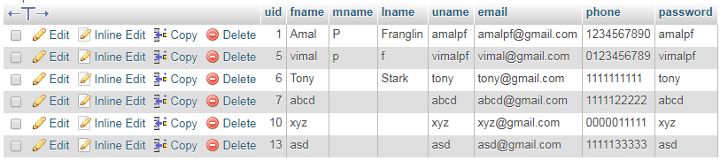

1. admin



1. halls

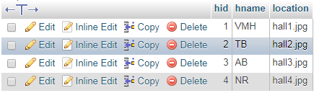

1. bookings

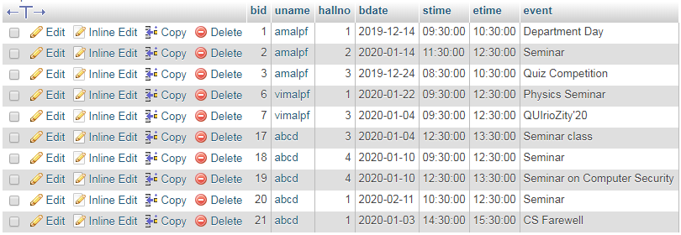

**4. SYSTEM DEVELOPMENT**

**SAMPLE**

Index or home Page:

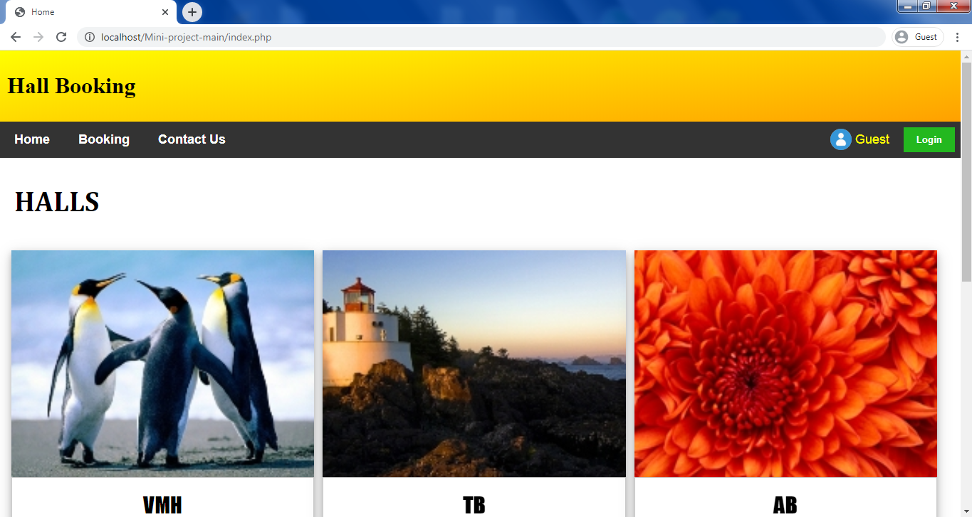

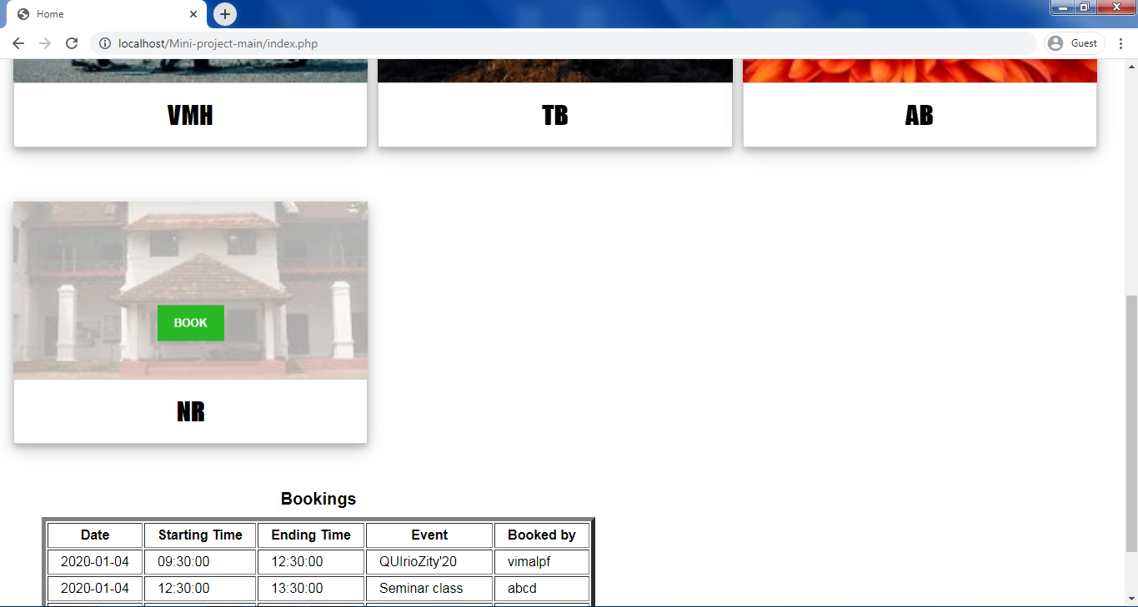

User Login:

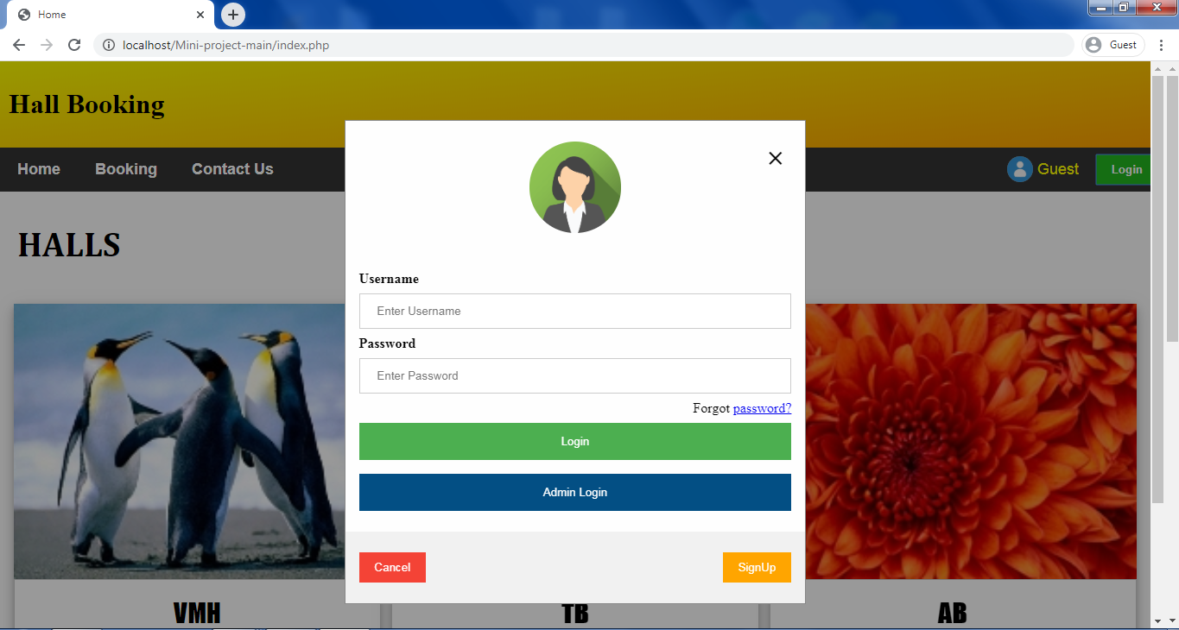

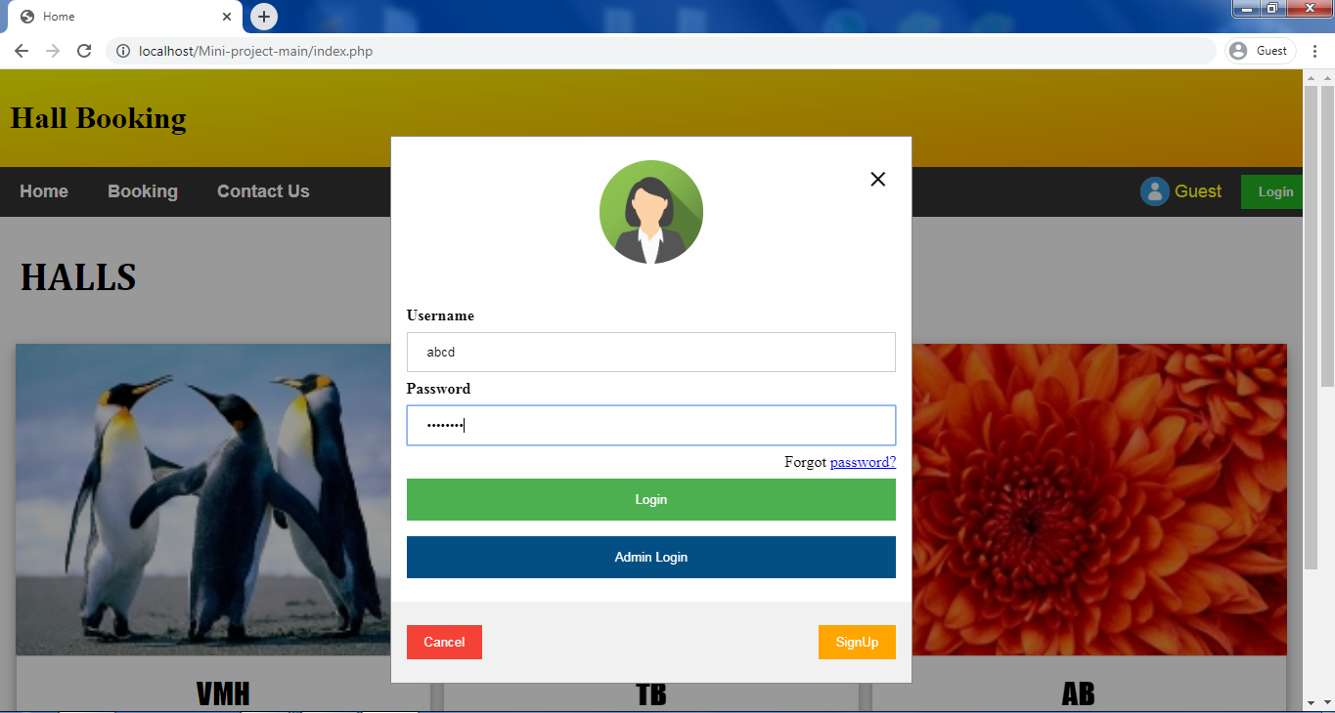

Logged in:

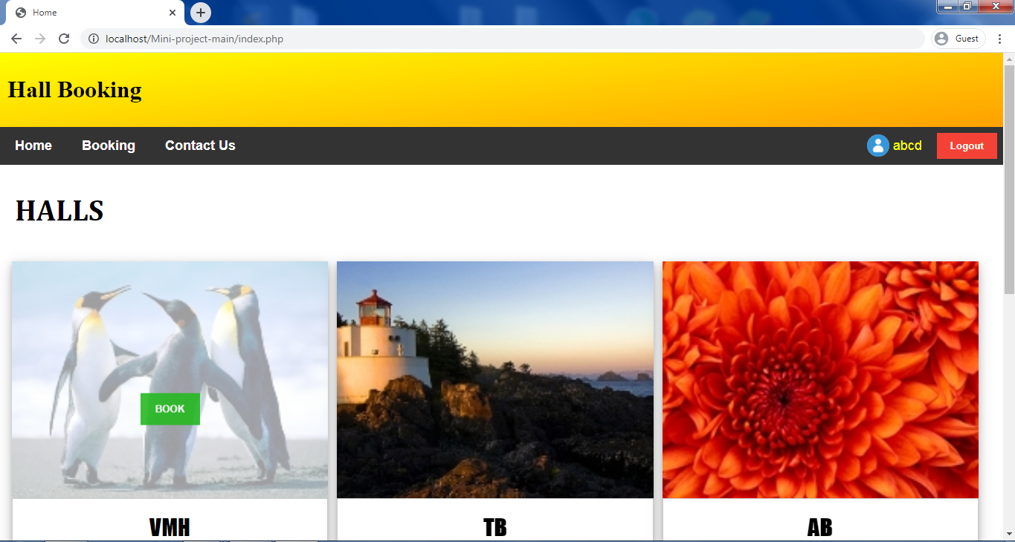

Booking page:

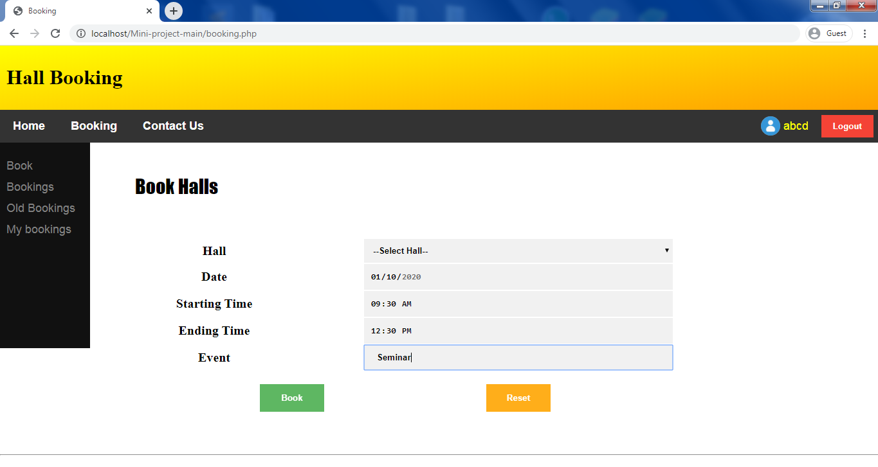

After booking:

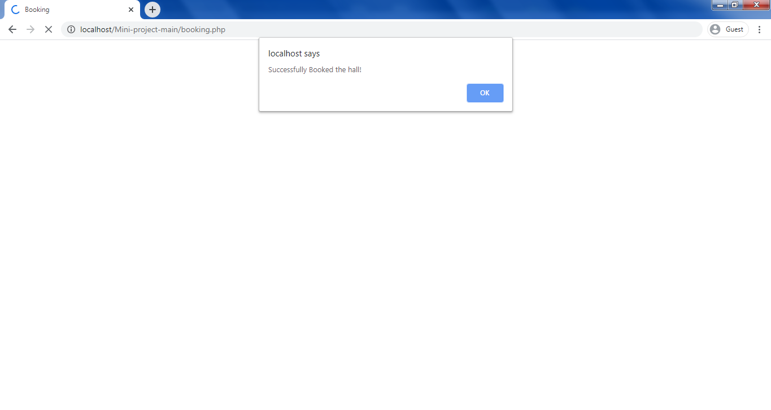

Bookings List:

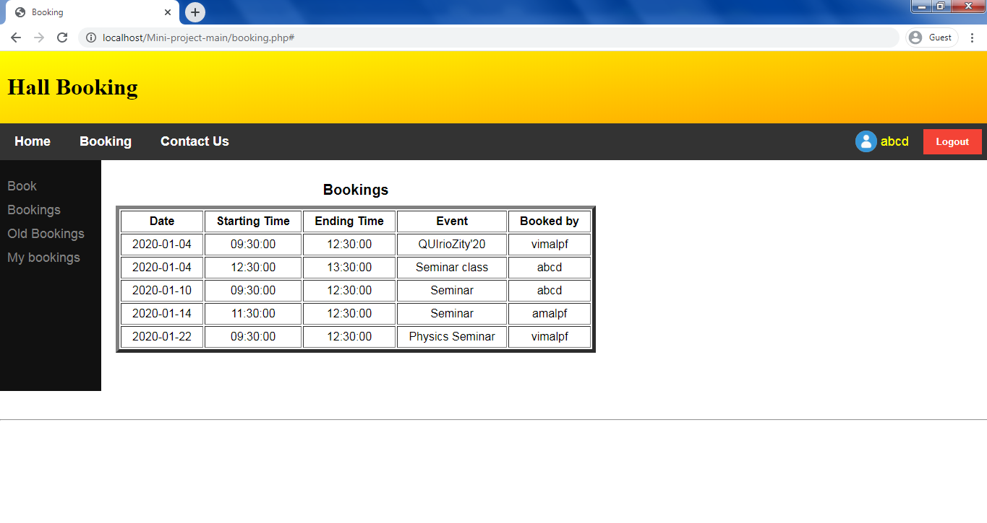

Old bookings list:

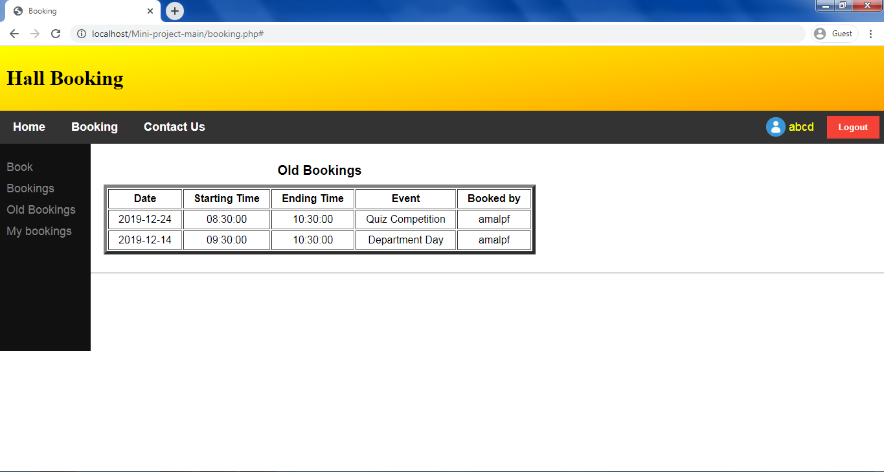

User bookings list:

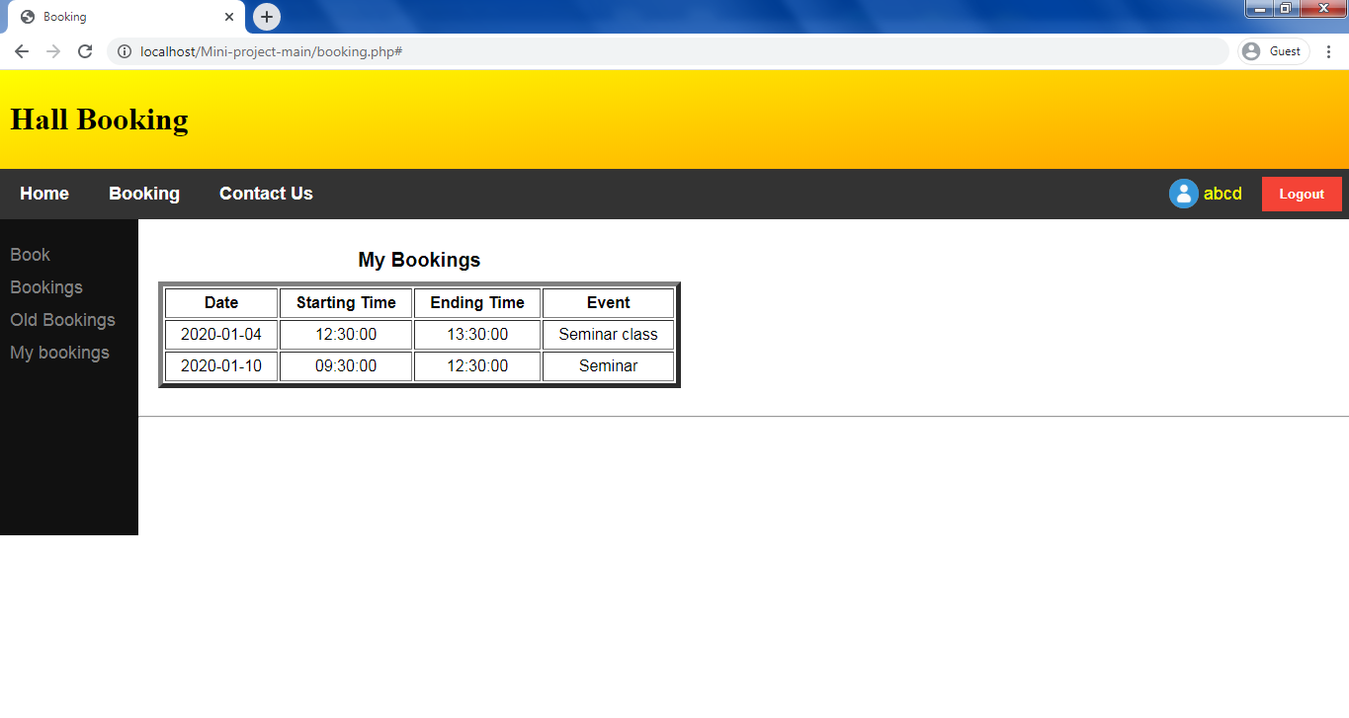

User Signup page:

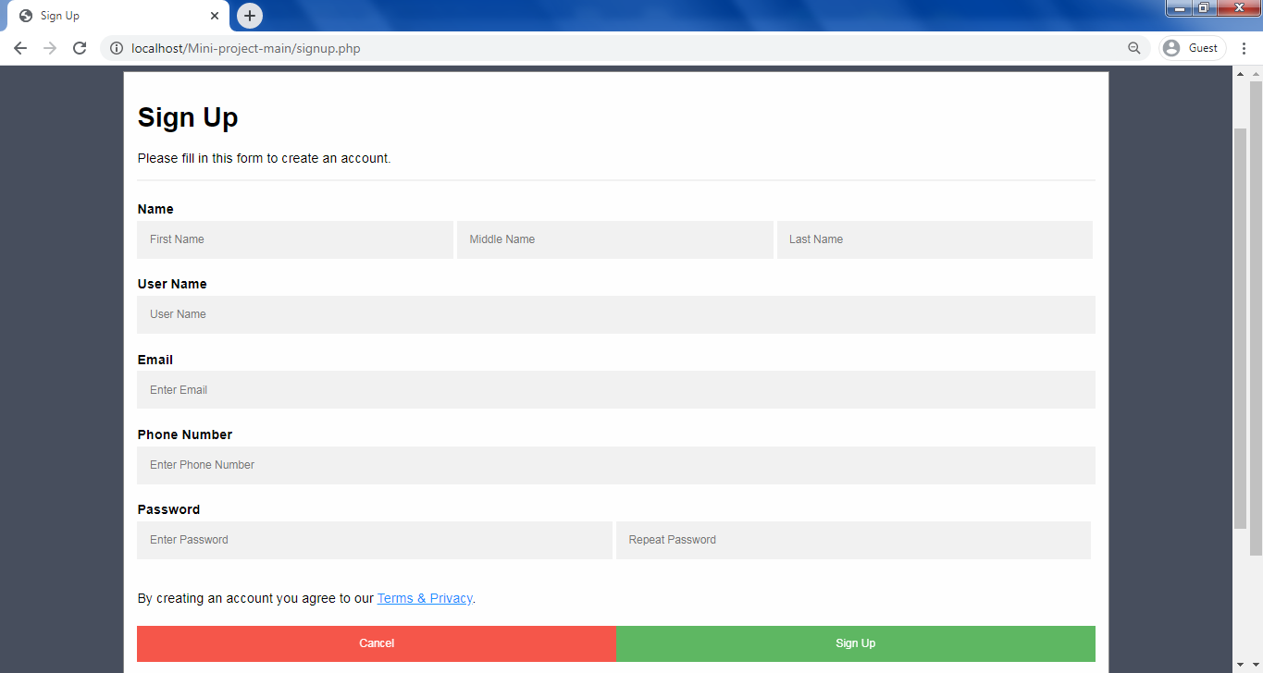

Signup verifications:

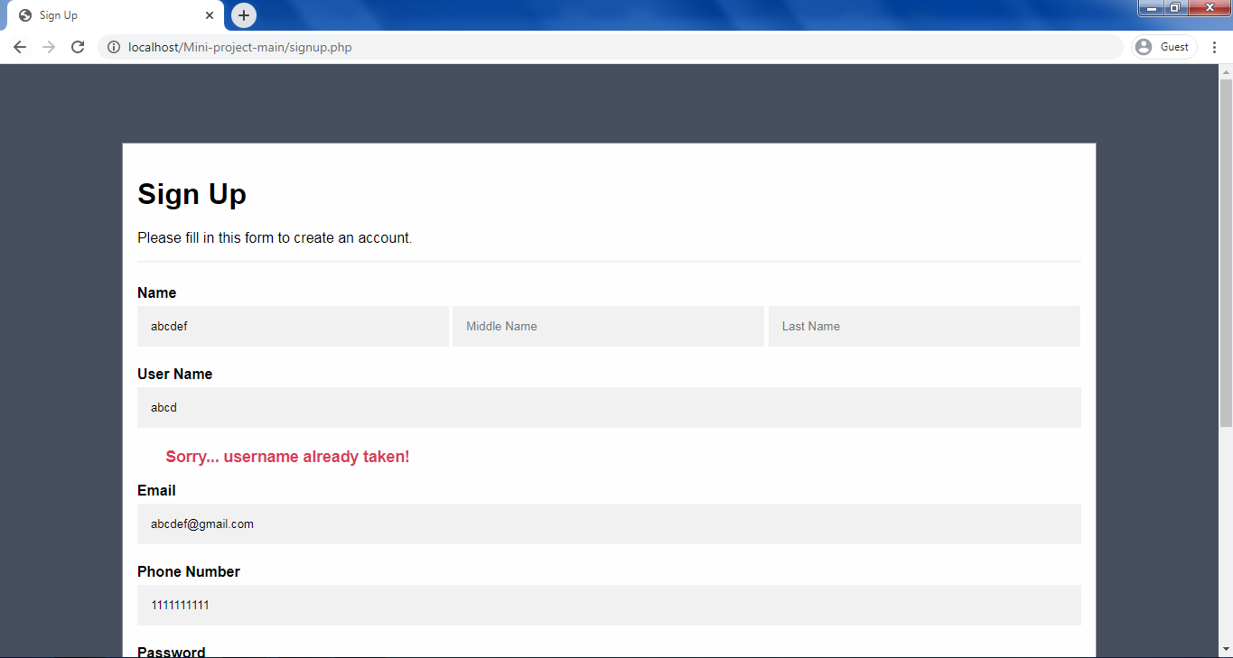

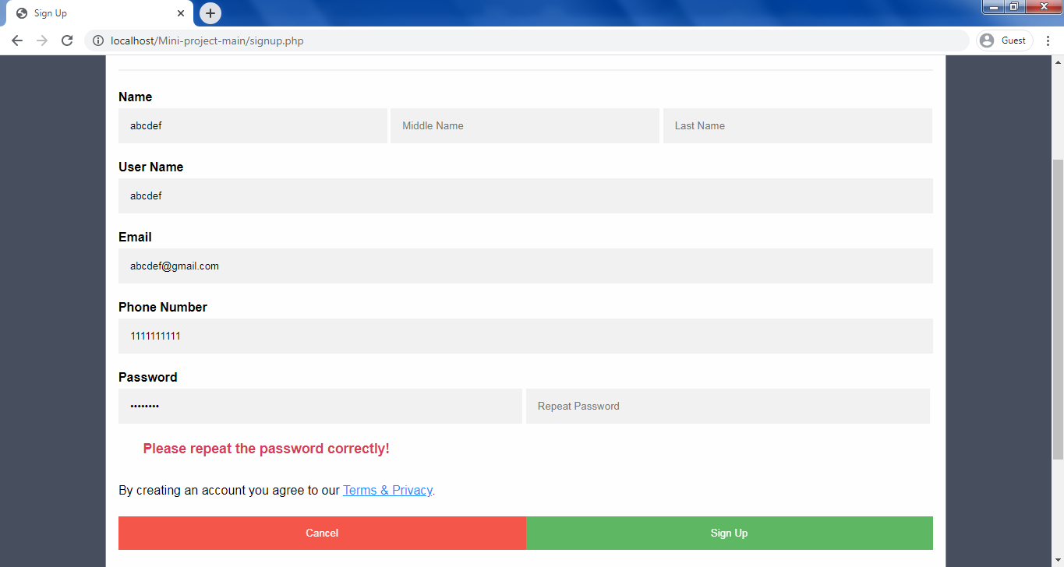

Admin Login:

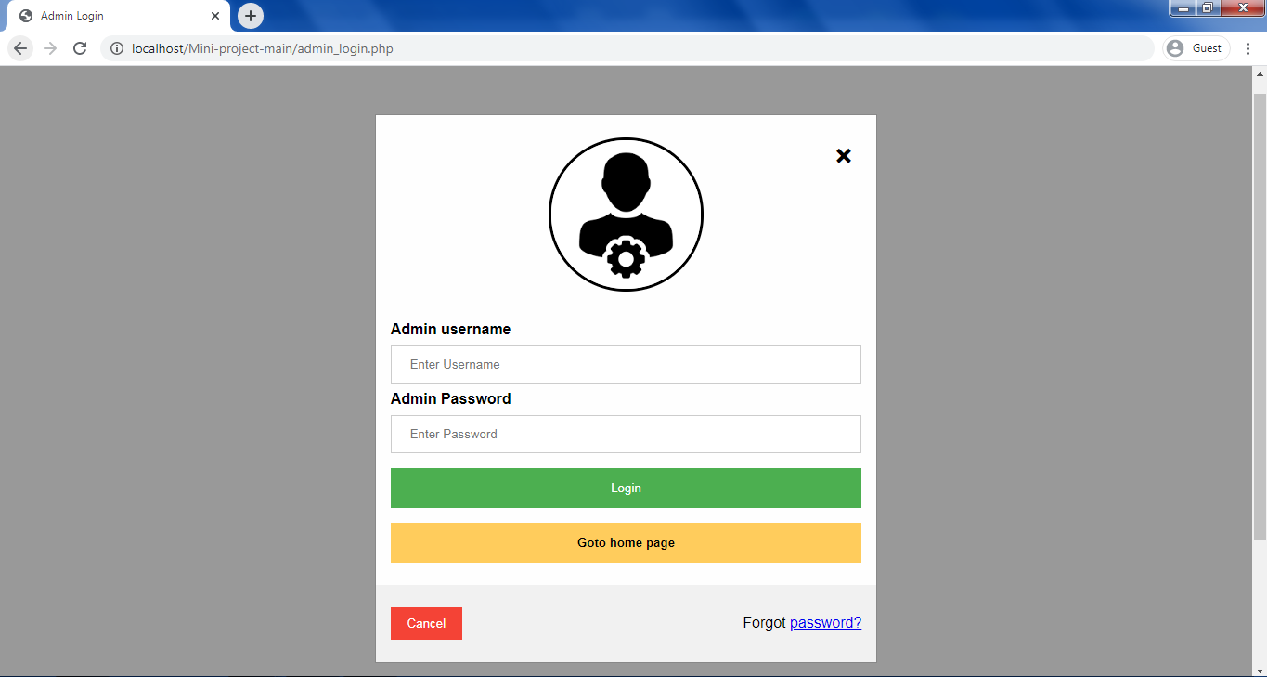

Admin Activities:

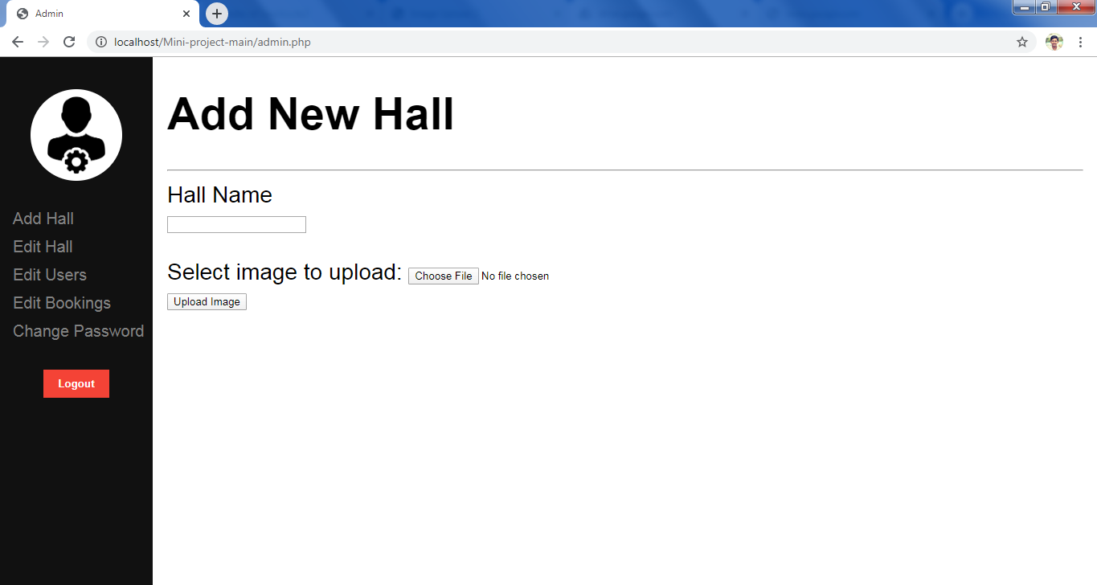

**5. SYSTEM TESTING**

**INTRODUCTION**

The philosophy behind testing is to find errors. Test cases are devised with this purpose in mind. A test case is a set of data that the system will process as normal input. However, the data are created with the express intend of determining whether the system will process correctly. When the testing is over the implementation stages comes. In this the software we so far created and tested are implemented, i.e., install the new application, check whether the existing equipment are for it and it also includes training to users of the software. Thus, the testing and implementation are two essential parts of the system development. Without this a system cannot be complete.

During system testing the system is used experimentally to ensure that the application does not fail. i.e., whether it will run according to its specifications and in the way user expect. Special test data are proceeded for processing and the results are examined. A limited number of users may be allowed to use the system so that the analyst can see whether they try to use it in the unforeseen ways.

During the test process, only failures are observed by which the presence of fault is deduced. The actual faults are identified by separate activities commonly referred to as debugging. In other words, for identifying faults, the expensive task of debugging has to be performed. This is one of the reasons why testing is an expensive method of identification of faults.

Here the system design was tested. Each of the units was tested individually and then the entire system was tested. The different test cases were supplied to see whether the application works, and the unit testing was successful. In that case the system testing was carried out. The entire module was demonstrated to see whether it satisfies the user needs. The system is tested using the various test cases. The test cases include the various distributions as part of which the developed system is tested to see whether it yields the necessary results. Let’s consider the testing of some of processes.

Software testing is a critical element of software quality assurance and represents the ultimate reviews of specification, design and coding. Testing presents an interesting anomaly for the software. Testing is vital to the success of system. Errors can be injected at any stage during development. System testing makes logical assumption that if all the parts of the system are correct, the goal will be successfully achieved. During testing, the program to be tested is executed with set of test data and output of the program for the test data is evaluated to determine if the program is performing as expected. A series of testing are performed for the proposed system before the system is ready for the acceptance testing. The testing steps are:

* Unit Testing
* Integration Testing
* Validation Testing
* Output Testing
* Acceptance Testing

**UNIT TESTING**

Unit testing focuses verification effort on the smallest unit of the software design, the module. This is also known as module testing, since the proposed system has modules in which the testing is individually performed on each module. Using the details and design description as a guide, important control paths are tested to uncover errors within the boundary of the module. This testing was carried out during programming stage itself. In this testing step, each module is found to be working satisfactorily as regards to the expected output from the module.

**INTEGRATION TESTING**

Data can be tested across an interface. One module can have adverse effect on another and sub-function when combined, may not produce the desired function. Integration testing is a systematic technique for constructing the program structure while at the same time conducting test to uncover errors associated with the interface.

#### VALIDATION TESTING

#### Validation testing can be defined in many ways, but a simple definition is that validation is said to be successful when the software functions in a manner that is reasonably expected by the customer. Software validation is achieved through a series of black box tests that demonstrates conformity with requirement. After the validation test has been conducted, one of the two conditions exists:

#### The function or performance characteristics conform to specifications and are accepted.

#### A validation from specification is uncovered and a deficiency created.

Deviation or errors discovered at this step in this project is corrected prior to completion of the project with the help of the user by negotiating to establish a method for resolving deficiencies. Thus, the proposed system under consideration has been tested by using validation testing and is found to be working satisfactorily.

**OUTPUT TESTING**

After performing validation testing, the next step is output testing of the proposed system, since no system could be useful if it does not produce the required output in the specific format. The output generated or displayed by the system under consideration is tested by asking the users about the format required by them. Here the output is considered in two ways: one is on screen and the other is printed format. The output format on the screen is found to be correct as the format was designed in the system design phase according to the user needs.

As far as hardcopies are considered it goes in terms with the user requirements. Hence output testing doesn’t result any correction in the system.

#### ACCEPTANCE TESTING

#### User acceptance of the system is a key factor for the success of any system. The system under consideration is tested for user acceptance by constantly keeping in touch with prospective system and user at the time of developing and marking changes whenever required.

#### TYPES OF TESTING

#### There are two types of testing: White Box testing and Black Box testing.

##### WHITE BOX TESTING

White box testing is a test case design method that uses the control structure of the procedural design to derive test cases. White box testing of software is predicted on close examination of procedural detail.

##### BLACK BOX TESTING

The black box testing focuses on the functional requirements of the software. It helps to find out errors in incorrect or missing functions, interface errors, errors in data structures, performance errors and initialization and termination errors. The black box testing is applied during the later stages for the functional requirement evaluation.

# 6. SYSTEM IMPLEMENTATION

### IMPLEMENTATION

### Implementation is the power of having the system personnel check-out and put new equipment into use, train users, install the new applications, etc. But when both the organization and the user changes, the environment will different over weeks and months. Therefore, the application will have to be maintained. That is modifications and changes will be made to the software, files etc.

### The system was being tested to see whether needs are being satisfied. The necessary guidance for the users of the system was also given so that they never enter any unwanted data. Maximum errors can be avoided as per user training that is a part of system implementation and maintenance.

### Implementation is the stage of the project when the theoretical design is turned into a working system. If the implementation stage is not properly planned and controlled, it can cause chaos. Thus it can be considered to be the most crucial stage in achieving a successful new system and in giving the users’ confidence that the new system will work and be effective.

### Normally, this stage involves setting up coordinating committee, which will act as a sounding board for ideas, complaints and problems. The first task is implementation planning; i.e., deciding the methods and timescale to be adopted. Apart from planning, the two major tasks of preparing for implementation are education and training of users and testing of the system. Education of users should really have taken emphasis on training the new skills to give the staffs confidence they can use the system. Once the staff has been trained, the system can be tested.

### After the implementation phase is completed and the user staff is adjusted to the changes created by the candidate system, evaluation and maintenance begin. The importance of maintenance is to continue bringing new standards to the system.

### The activities of implementation phase can be summarized as:

### Implementation Planning

### Education and Training

### System Training

System implementation is the final phase i.e., putting the utility into action. Implementation is the state in the project where theoretical design turns into working system. The most crucial stage is achieving a new successful system and giving confidence in new system that it will work efficiently and effectively. The system is implemented only after thorough checking is done and if it is found working in according to the specifications.

It involves careful planning, investigation of the current system and constraints on implementation, design of methods to achieve. Two layers of checking is done and if it is found working according to the specification, major task of preparing the implementation are educating, training the users.

The implementation process begins with preparing a plan for the implementation of the system. According to this plan, the activities are to be carried out, discussions made regarding the equipment and resources and the additional equipment has to be acquired to implement the new system. The most important in implementation stage is, gaining the users confidence that the new system. The most important in the implementation stage is, gaining the users confidence that the new system will work and be effective. The system can be implemented only after through testing is done. This method also offers the greater security since the existing system can take over if the errors are found or inability to handle certain type of transactions while using the new system.

**CONCLUSION**

The system, as the name indicates, is a software to save the time and cost in managing the hall booking process in college.

By using the system anyone (student or teacher of college) can book a hall, look for date available, previously booked activities, etc. The application is easy to handle since the system gives emphasis to the important information of the user. The system gives more importance to the user by eliminating the possibility of errors.

The various features provided by the application are book any available hall, check the new and old bookings done by the user and also by other users, etc. All of these features can be strictly monitored by the administrator account.

The various processes of the construction of new system are done. The allocation processes are effective and easy to handle, with good look and feel environment. The web application will satisfy the user need and thus, reduces the work done and time.

The system is a user friendly web application with less time needed to learn how to operate the system. “HALL BOOKING” successfully overcome strict and severe validation check performed using test data. The result attained where fully satisfactory from the user point of view. An attempt was made to obtain maximum perfection in documenting the software in a simple, precise and self-explanatory manner.

The system can modified as per the user need in the future.

**BIBLIOGRAPHY**

* Programming PHP by Rasmus Lerdorf.
* Learning PHP, MySQL, JavaScript, CSS & HTML5: A Step-by-Step Guide to Creating Dynamic Websites by Robin Nixon.
* <https://www.w3schools.com>
* <https://stackoverflow.com>
* <https://www.quora.com>
* <https://www.tutorialspoint.com/index.htm>
* <https://www.geeksforgeeks.org>
* <https://www.php.net>
* <https://developer.mozilla.org/en-US>
* <https://html-css-js.com>
* <https://www.w3docs.com>
* [https://perishablepress.com](https://perishablepress.com/go-back-via-javascript-and-php/)
* <https://www.tutorialrepublic.com>